**SQL (Structured Query Language)**

**Assignments**

**Assignment\_part1\_DDL&DML**

**1. Create a database called 'assignment' (Note please do the assignment tasks in this database)**

**Query:**

**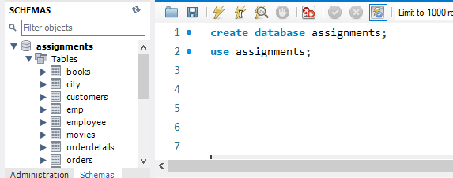**

**2. Create the tables from assignment\_tables.sql and enter the records as specified in it.**

**3. Create a table called authors with the following columns authorid, name**

**- choose appropriate datatypes for the columns**

**Query:**

**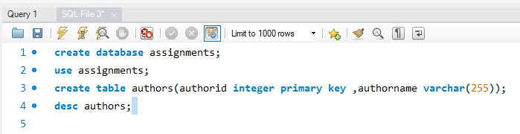**

**Output:**

**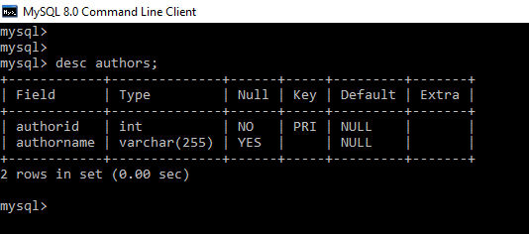**

**a) Insert the following data into the table**

**1, J K Rowling**

**2, Thomas Hardy**

**3, Oscar Wilde**

**4, Sidney Sheldon**

**5, Alistair Maclean**

**6, Jane Austen**

**Query:**

**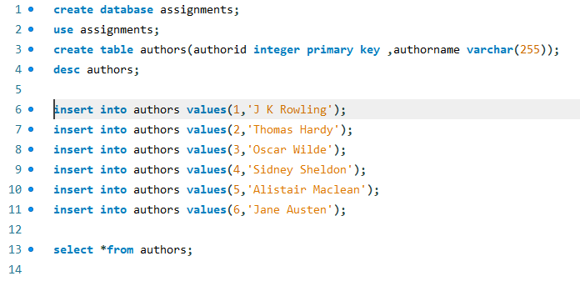**

**Output:**

**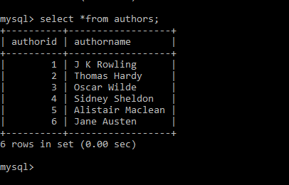**

**b) Add a couple of authors of your choice**

**Query:**

**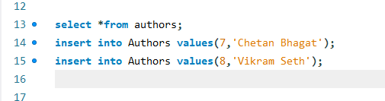**

**Output:**

**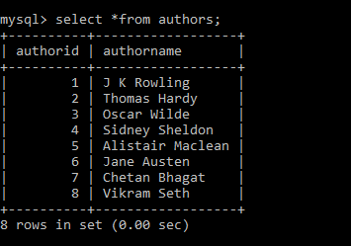**

c) Change 'Alistair Maclean' to 'Alastair McNeal'

**Query:**

**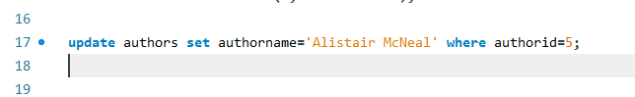**

**Output:**

**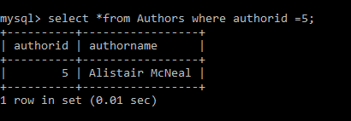**

**4. Create a table called Books with the following columns bookid, title, and authorid**

**- choose appropriate datatypes for the columns**

**Query:**

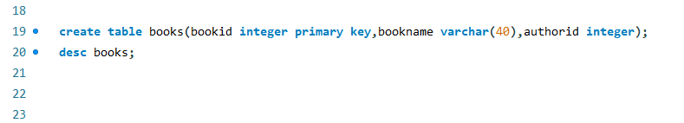

**Output:**

**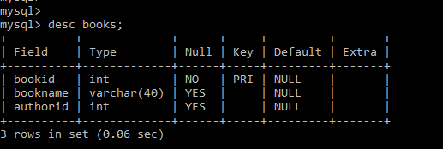**

1. **Insert the following records**

**1, Harry Potter and the Philosopher's Stone, 1**

**2, Harry Potter and the Chamber of Secrets, 1**

**3, Harry Potter and the Half-Blood Prince, 1**

**4, Harry Potter and the Goblet of Fire, 1**

**5, Night without End, 5**

**6, Fear is the Key, 5**

**7, Where Eagles Dare, 5**

**8, Sense and Sensibility, 6**

**9, Pride and Prejudice, 6**

**10, Emma, 6**

**11, Random Book, 22**

**Query:**

**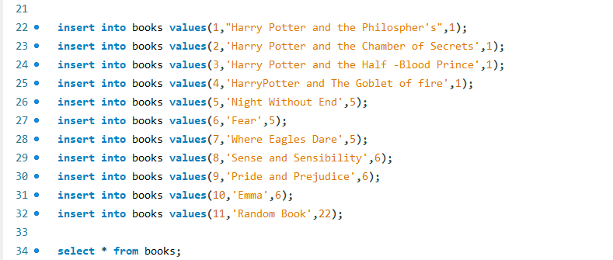**

**Output:**

**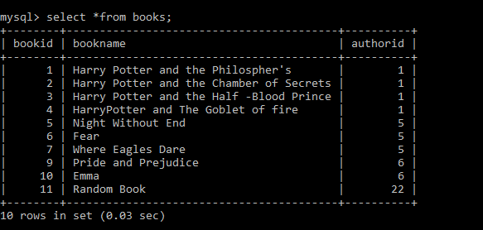**

b) Delete 'Random Book' from the table.

**Query:**

**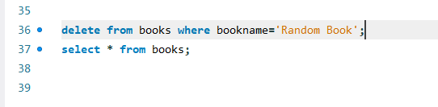**

**Output:**

**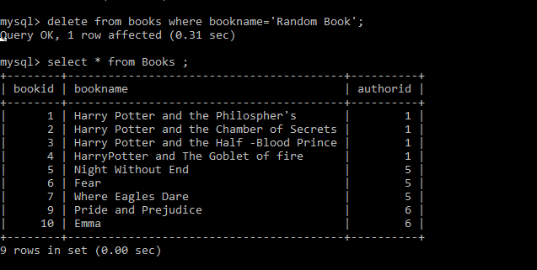**

5. Rename the table Books to Favbooks and Authors to Favauthors.

**Query:**

****

**Output:**

**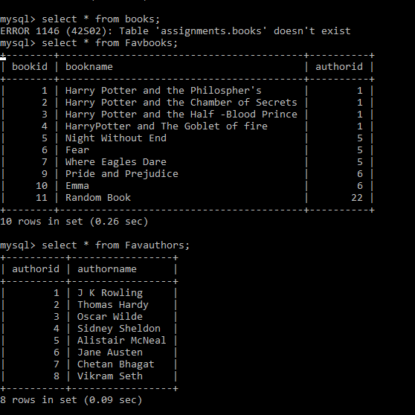**

6. Create the following tables. Use auto increment wherever applicable

a. Products

product\_id - primary key

product\_name - cannot be null and only unique values are allowed

description

supplier\_id - foreign key of supplier table

b. Suppliers

supplier\_id - primary key

supplier\_name

location

c. Stock

id - primary key

product\_id - foreign key of product table

balance\_stock

**Query:**

**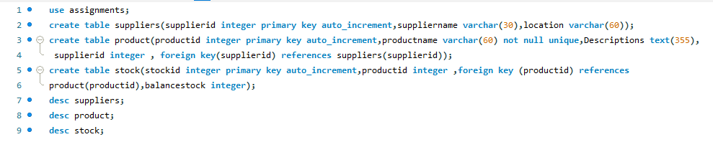**

**Ouput:**

**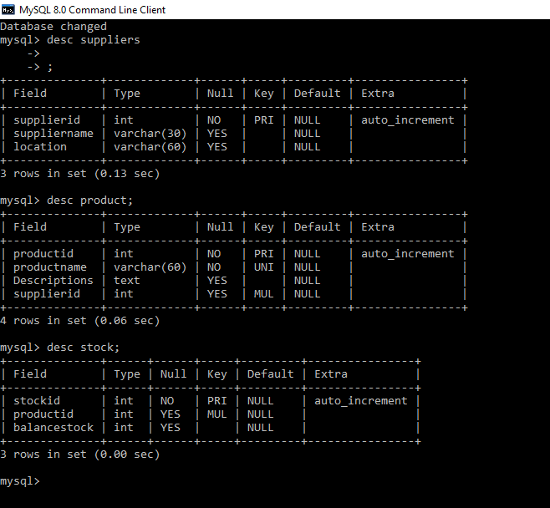**

7. Enter some records into the three tables.

**Query:**

**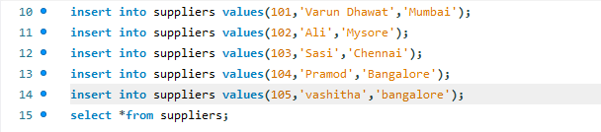**

**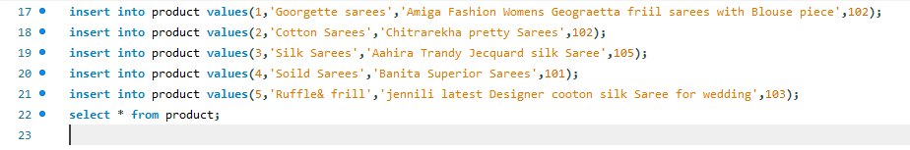**

**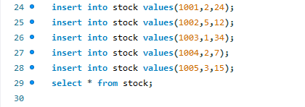**

**Output:**

**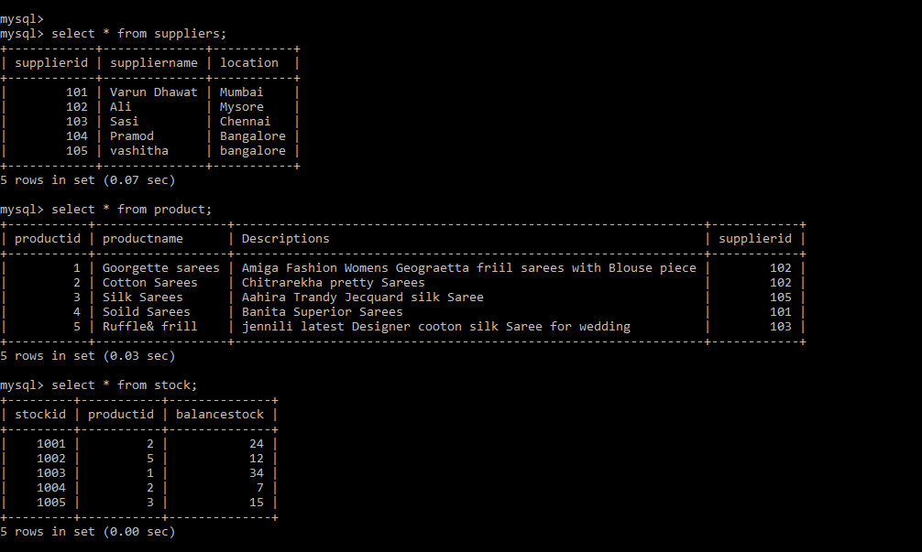**

8. Modify the supplier table to make supplier name unique and not null.

**Query:**

****

**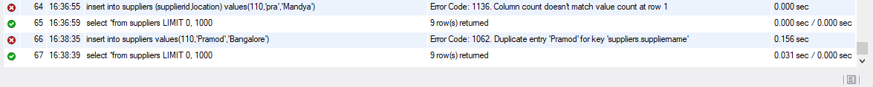**

**Output:**

**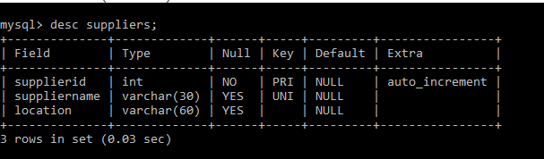**

9. Modify the EMP table as follows

a. Add a column called deptno

b. Set the value of deptno in the following order

deptno = 20 where emp\_id is divisible by 2

deptno = 30 where emp\_id is divisible by 3

deptno = 40 where emp\_id is divisible by 4

deptno = 50 where emp\_id is divisible by 5

deptno = 10 for the remaining records.

**Given records:**

**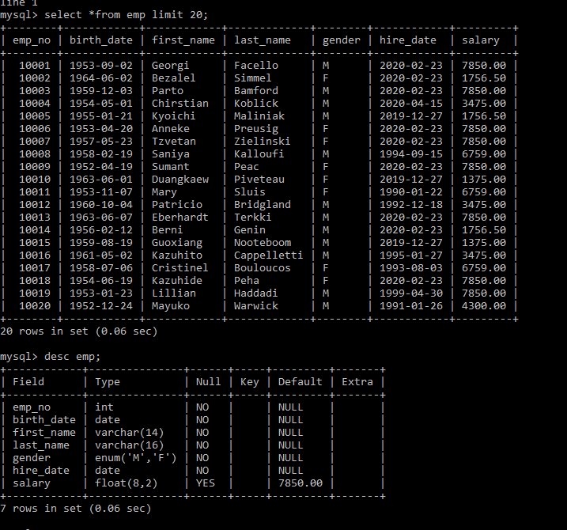**

1. Add a column called deptno

**Query:**

**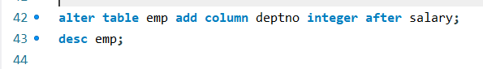**

**Output:**

**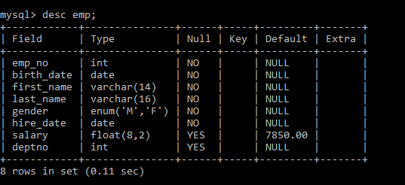**

**Query:**

**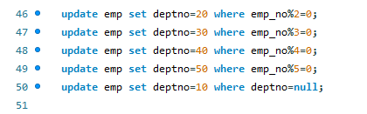**

**Output:**

**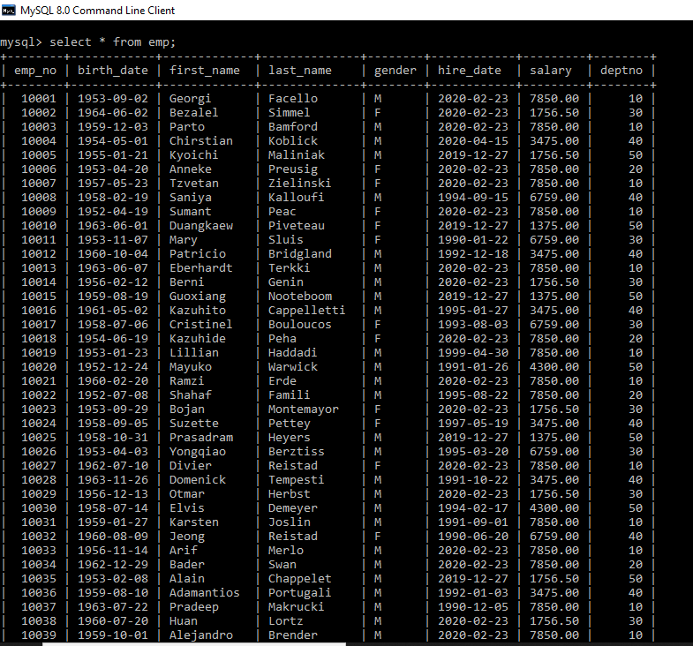**

**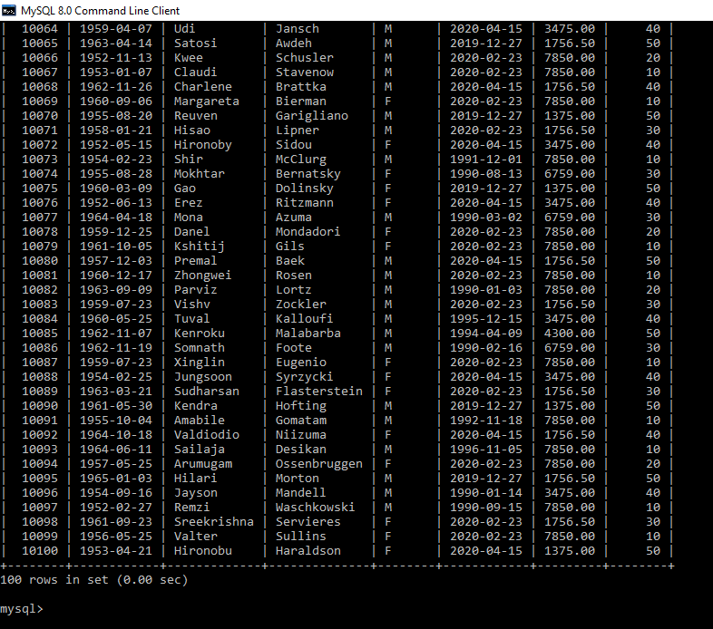**

10. Create a unique, hash index on the emp\_id column.

**Query:**

****

**Assignment\_part\_2\_DML**

1. select all employees in department 10 whose salary is greater than 3000. [table: employee]

**Query:**

**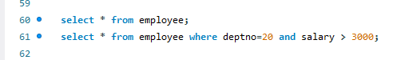**

**Output:**

**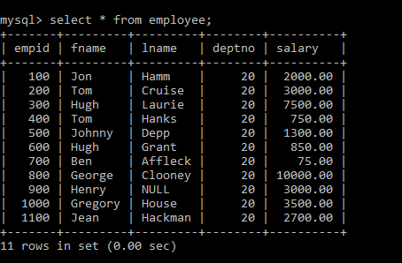**

**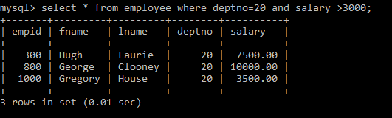**

2. The grading of students based on the marks they have obtained is done as follows

40 to 50 -> Second Class

50 to 60 -> First Class

60 to 80 -> First Class

80 to 100 -> Distinctions

a. How many students have graduated with first class?

b. How many students have obtained distinction? [table: students]

Query:

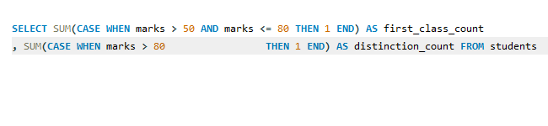

**Output :**

**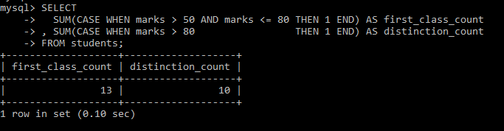**

3. Get a list of city names from station with even ID numbers only. Exclude duplicates from your answer.[table: station]

**Explanation:** There are 501 id been record in that excluding duplicate record we have 471 records applied on it.

**Query:**

**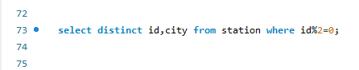**

**Output:**

**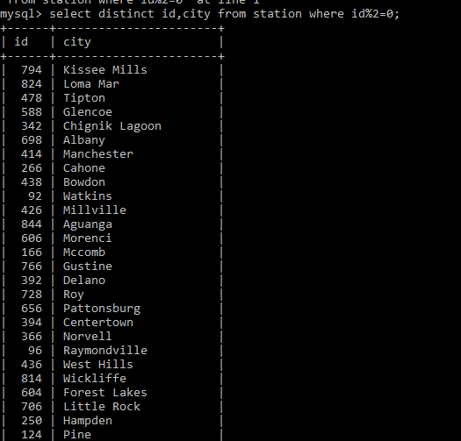**

**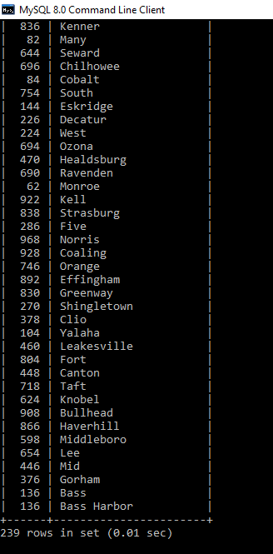**

4. Find the difference between the total number of city entries in the table and the number of distinct city entries in the table. In other words, if N is the number of city entries in station, and N1 is the number of distinct city names in station, write a query to find the value of N-N1 from station.[table: station]

**Query:**

**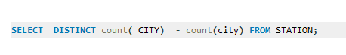**

**Output:**

**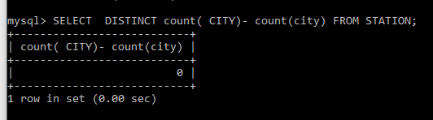**

5. a. Query the list of CITY names starting with vowels (i.e., a, e, i, o, or u) from STATION. Your result cannot contain duplicates. [Hint: Use RIGHT() / LEFT() methods ]

b. Query the list of CITY names from STATION which have vowels (i.e., a, e, i, o, and u) as both their first and last characters. Your result cannot contain duplicates.

c. Query the list of CITY names from STATION that do not start with vowels. Your result cannot contain duplicates.

d. Query the list of CITY names from STATION that either do not start with vowels or do not end with vowels. Your result cannot contain duplicates. [table: station]

**Query:**

**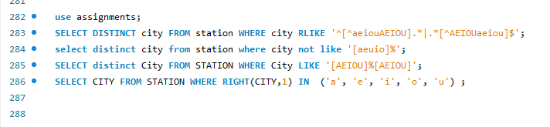**

**Output:**

**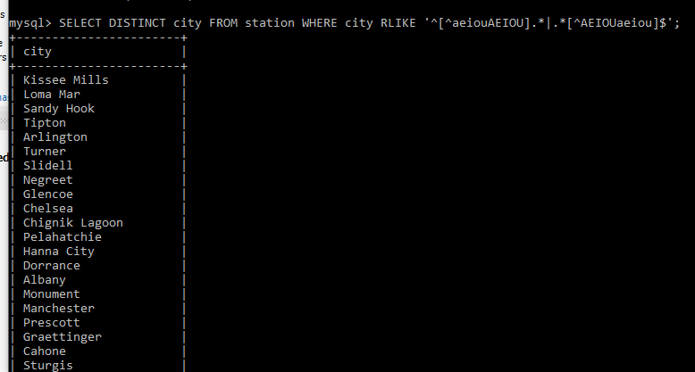**

**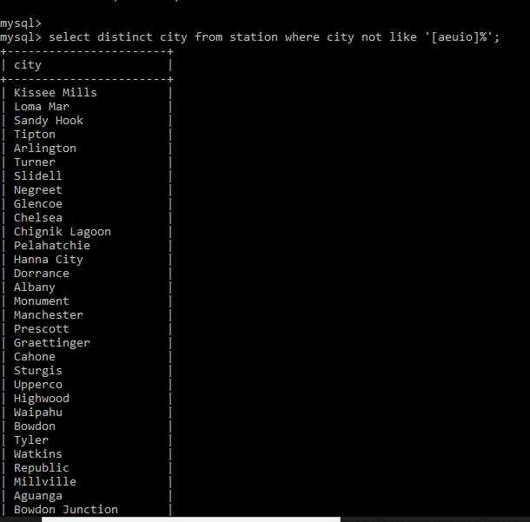**

**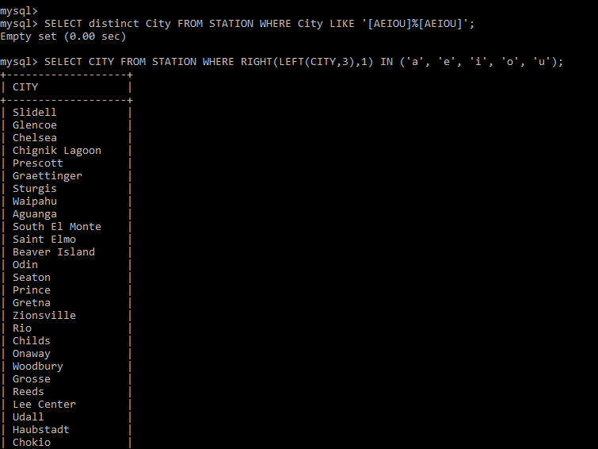**

7. Write a query that prints a list of employee names having a salary greater than $2000 per month who have been employed for less than 10 months. Sort your result by ascending emp\_id. [table: emp]

**Query:**

**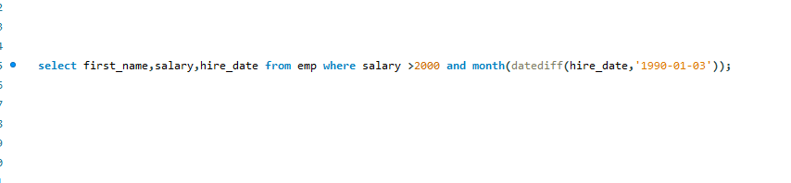**

**Output:**

**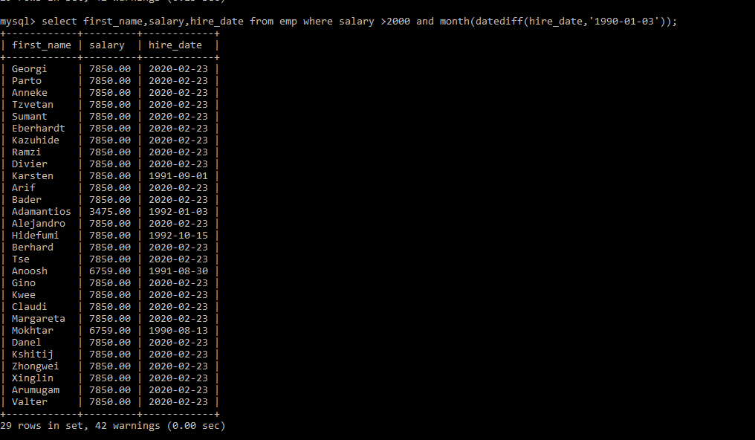**

8. 12. How much money does the company spend every month on salaries for each department? [table: emp]

Expected Result:

+-------------+--------+

| sum(salary) | deptno |

+-------------+--------+

| 30700.00 | 10 |

| 13600.00 | 20 |

| 2600.00 | 30 |

+-------------+--------+

**Query:**

**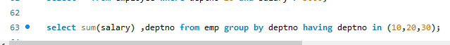**

**Output:**

**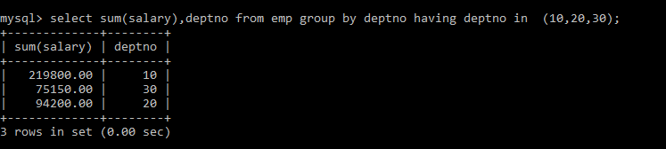**

9. How many cities in the CITY table have a Population larger than 100000. [table: city]

Query:

**C:\Users\Ostrich_Sales_Mgmt\Pictures\Screenshots\Screenshot (159).png**

**Output:**

**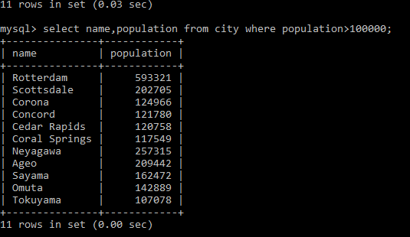**

10. What is the total population of California? [table: city]

**Query:**

**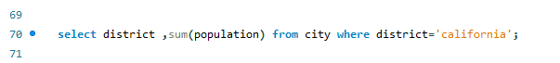**

**Output:**

**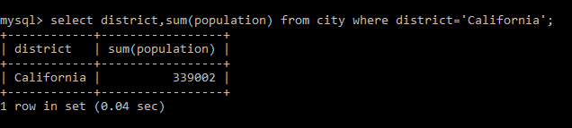**

11. What is the average population of the districts in each country? [table: city]

Expected Result:

+-------------+-----------------+

| countrycode | avg(population) |

+-------------+-----------------+

| JPN | 175839.2000 |

| NLD | 593321.0000 |

| USA | 120225.8750 |

+-------------+-----------------+

**Query:**

**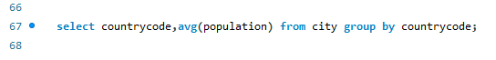**

**Output:**

**